Maine Department of Transportation

FHWA TITLE VI PROGRAM FFY 2023 IMPLEMENTATION PLAN

Submitted by: Sherry Y. Tompkins, Director, Civil Rights Office October 1, 2022

Table of Contents
INTRODUCTION 2
AUTHORITIES 3
- TITLE VI STANDARD ASSURANCES 4
- ORGANIZATION AND STAFFING 4
- PROGRAM REVIEW PROCEDURES 5
- SUBRECIPIENT REVIEW PROCEDURES 10
- DATA COLLECTION-REPORTING-ANALYSIS 12
- TITLE VI TRAINING 17
- COMPLAINT PROCEDURES 18
- DISSEMINATION OF TITLE VI INFORMATION 21
- REVIEW OF MAINEDOT DIRECTIVES 23
- COMPLIANCE AND ENFORCEMENT PROCEDURE 23
- LIMITED ENGLISH PROFICIENCY (Language Access Plan) 24

STANDARD TITLE VI / NONDISCRIMINATION ASSURANCES DOT ORDER NO. 1050.2A APPENDIX A - PERFORMANCE REQUIREMENTS
APPENDIX B - CLAUSES FOR DEEDS TRANSFERRING UNITED STATES PROPERTY
APPENDIX C - CLAUSES FOR TRANSFER OF REAL PROPERTY ACQUIRED OR IMPROVED UNDER THE ACTIVITY, FACILITY, OR PROGRAM
APPENDIX D - CLAUSES FOR CONSTRUCTION / USE / ACCESS TO REAL PROPERTY ACQUIRED UNDER THE ACTIVITY, FACILITY, OR PROGRAM
APPENDIX E
ATTACHMENT 1 - NONDISCRIMINATION POLICY STATEMENT
ATTACHMENT 2 - FEDERAL HIGHWAY ADMINISTRATION CIVIL RIGHTS ASSURANCE ATTACHMENT 3 - MAINEDOT ORGANIZATIONAL STRUCTURE
APPENDIX F - SAMPLE QUESTIONS FOR PROGRAM AREA REVIEWS APPENDIX G - SUBRECIPIENT CHECKLIST FOR TITLE VI REVIEWS APPENDIX H - SUBRECIPIENT COMPLIANCE ASSESSMENT TOOL APPENDIX I - TITLE VI COMPLAINT FORM
APPENDIX J - NONDISCRIMINATION / TITLE VI POSTER APPENDIX K - KNOW YOUR RIGHTS BROCHURE

INTRODUCTION

The Maine Department of Transportation (MaineDOT) is committed to ensuring that the fundamental principles of equal opportunity are upheld in all decisions involving our employees, our subrecipients and our contractors/consultants, and to ensuring that all members of the public are afforded access to our programs and services. To that end, no person shall be excluded from participation in, be denied the benefits of, or be otherwise subjected to discrimination under any MaineDOT program or activity on the basis of race, color or national origin.

MaineDOT is a recipient of federal funds from the U.S. Department of Transportation modal agencies, including the Federal Highway Administration (FHWA) and the Federal Transit Administration (FTA). All recipients of federal funding must comply with the requirements of Title VI of the Civil Rights Act of 1964 and other nondiscrimination statutes, regulations and authorities. This Implementation Plan describes how MaineDOT accomplishes nondiscrimination in the delivery of its federally assisted programs, services, and activities. The Plan includes the structure of MaineDOT’s Title VI program as well as the policies, procedures, and practices MaineDOT uses to comply with nondiscrimination requirements. The Plan is intended to be a living document, regularly monitored and updated by MaineDOT to reflect the program as it changes and grows. Anyone who wishes to provide input into MaineDOT’s Title VI Program Implementation Plan is encouraged to contact the Director of the Civil Rights Office, Sherry Y. Tompkins, at (207) 624-3066 or sherry.tompkins@maine.gov, or by writing to the Civil Rights Office at MaineDOT Headquarters, 16 State House Station, Augusta, ME 04333- 0016.

AUTHORITIES

- Title VI of the Civil Rights Act of 1964 (42 U.S.C. § 2000d et seq., 78 stat. 252), (prohibits discrimination on the basis of race, color, national origin);

- 49 CFR Part 21 (entitled Nondiscrimination in Federally-Assisted Programs of the Department of Transportation—Effectuation of Title VI of the Civil Rights Act of 1964);

- 23 CFR Part 200 (FHWA’s Title VI Regulation);

- 28 CFR Part 50.3 (DOJ Guidelines for Enforcement of Title VI of the Civil Rights Act of 1964);

- The Civil Rights Restoration Act of 1987;

- US DOT Order 1050.2A (Federal DOT assurances surrounding Title VI and prohibiting discrimination on the grounds of race, color or national origin within programs where the recipient receives federal financial assistance from DOT);

- Executive Order #12898 (Federal Actions to Address Environmental Justice in Minority Populations and Low-Income Populations);

- Executive Order #13166 (Improving Access to Services for Persons with Limited English Proficiency.

TITLE VI STANDARD ASSURANCES

In accordance with USDOT Order 1050.2A, a copy of MaineDOT’s Title VI Nondiscrimination Assurances signed by MaineDOT’s Commissioner is attached.

ORGANIZATION AND STAFFING

The Commissioner of MaineDOT is responsible for ensuring the implementation of MaineDOT’s Title VI program. The Civil Rights Director, on behalf of the Commissioner, is responsible for the overall management of the Title VI program. The day-to-day administration of the program is undertaken by the Civil Rights Office, under the supervision of the Chief Legal Counsel. The Civil Rights Office has, direct access to the Commissioner. The Civil Rights Director has lead responsibility for coordinating the administration and implementation of Title VI and related statutes program, plan, and assurances. The Civil Rights Director delegates some Title VI duties to the EEO Officers and to Title VI Liaisons in program areas. The Liaisons work with the Civil Rights Office to administer the Program in their respective areas. See Organizational Chart attached as Attachment 3.

CIVIL RIGHTS TITLE VI OFFICE STAFF

Director, Civil Rights Office | Sherry Y. Tompkins Title VI Coordinator | (207) 624-3066 | sherry.tompkins@maine.gov
EEO Program Specialist | Stacie Haskell DBE Program  Administration, Title VI Coordinator | (207) 624-3056 | stacie.haskell@maine.gov
EEO Program Specialist | Jennifer Laliberte OJT Administration, Labor Compliance | (207) 624-3036 | jennifer.e.laliberte@maine.gov

Duties of the Civil Rights Office
  - Coordinate Title VI Program development and implementation with internal and external program areas.
  - Conduct Title VI reviews of internal program areas, MPOs and subrecipients to ensure compliance.
  - Provide or secure Title VI training for DOT internal staff and subrecipients
  - Complete MaineDOT’s Title VI Implementation Plan for submission to FHWA by October 1st each year.
  - Complete MaineDOT’s Title VI Annual Accomplishment Report for submission to FHWA by November 1st of each year.
  - Complaint investigation and resolution.
  - Distribute and, where necessary, ensure translation and include braille of Title VI documents to the public.

  - Review MaineDOT program manuals, contracts, and policy documents to determine whether Title VI is appropriately addressed and implemented agency wide.
  - Work collaboratively with federal and state authorities in communicating Title VI program requirements.
  - Review agency directives to determine if there are any Title VI implications.
  - Provide or secure Title VI technical assistance, guidance, and training to MaineDOT staff, state officials, municipalities, Local Public agencies, contractors, consultants, and other recipients of federal-aid highway funding.
  - Develop and conduct Title VI reviews of program area activities annually.
  - Develop and publish Title VI information for dissemination to the general public and where appropriate, ensure that the information is translated in languages other than English.
  - Implement procedures for prompt processing and disposition of Title VI complaints.
  - Assist in the collection of demographic data.
  - Review contractual procedures for consultants and contractors to ensure equity and consistency.
  - Provide FHWA with quarterly update reports.

PROGRAM REVIEW PROCEDURES

Title VI Liaisons in Programs

In addition to the Title VI Coordinator, each of MaineDOT’s program areas will have a designated Title VI Liaison. The program areas are:

  - Bureau of Planning: Public Outreach & Planning and Transportation Systems Analysis
  - Bureau of Project Development
    - Property Office
    - Multimodal Program
    - Contracts Office
  - Bureau of Maintenance and Operations
  - Environmental Office
  - Safety Office

The Liaisons are responsible for ensuring Title VI development in their respective areas, sharing Title VI information, resources and ensuring compliance of their subrecipients, Title VI program monitoring, and reporting to the Civil Rights Office the goals and results of their respective areas. Each program area is responsible for performing a self- assessment to determine which personnel interact with members of the public.

Title VI Responsibilities

Bureau of Planning
Planning develops MaineDOT’s Annual Work Plan, the Statewide Transportation Improvement Program (STIP) and the Public Involvement Plan to meet present and future

transportation needs for safe, adequate, and efficient transportation and include all stakeholders and users in that process. The Regional Planning Commissions (RPCs) and the Metropolitan Planning Organizations (MPOs) provide information in developing these planning documents.

The Bureau’s Title VI Liaison will:

- Serve as a resource person for the Bureau of Planning. Help to develop and document procedures that ensure participation of a cross-section of people representative of the population(s) affected by Department projects, including identifying and proactively reaching out to various and diverse social, economic, and ethnic interest groups, and ensure the groups are represented in the planning process.
- Provide information to Planning staff, MPOs, and RPCs regarding Title VI.
- Provide statistical data on race, color, and national origin of populations in all areas impacted by the Department’s programs or services, including LEP.
- Ensure equal opportunity for participation on RPCs.
- Ensure Title VI language is included in every Bureau of Planning subrecipient contract.
- Address any complaints received with the Title VI Coordinator.
- Provide the Civil Rights Office with a quarterly report regarding projects indicating the relative benefits, services and any adverse impacts and its alternatives on persons and businesses of majority and minority, racial, national origin, and/or low-income groups, including but not limited to LEP persons.
- Provide the Civil Rights Office with an annual report of Title VI accomplishments and/or any issues for this year and any changes for the next year. Report is due by September 15th of each year.

Bureau of Project Development

Project Development oversees complete multiple phases of construction projects including: advertising for and awarding bids (Contracts), conducting public hearings with the Bureau of Planning, acquisition of real property interests to accommodate highway, bridge and multi-modal facilities, relocating persons and businesses pursuant to the Uniform Relocation and Assistance Act of 1970, and supervising construction of Department projects to completion.

The Bureau’s Title VI Liaison will:

- Monitor all Project Development activities to ensure nondiscrimination within program areas.
- Perform reviews of Title VI subrecipients to ensure Title VI adherence.
- Ensure Title VI language is included in every Bureau of Project Development program area subrecipient contract and subcontract.
- Serve as a resource person for the Bureau of Project Development. Help to develop and document procedures that ensure participation of a cross-section of people representative of the population(s) affected by Department projects,

including identifying and proactively reaching out to various and diverse social, economic, and ethnic interest groups, and ensure the groups are represented in the planning process.
- Provide information to program area staff regarding Title VI.
- Address any complaints received with the Title VI Coordinator.
- Provide the Civil Rights Office with a quarterly report regarding projects indicating the relative benefits, services and any adverse impacts and its alternatives on persons and businesses of majority and minority, racial, national origin, and/or low-income groups, including but not limited to LEP persons.
- Provide the Title VI Coordinator with an annual report on Title VI accomplishments and/or issues and methods used for this year and any changes for the next year. Report is due to the Civil Rights Office by September 15th of each year.

Property Office

MaineDOT’s Property Office provides support for Programs in the area of the traditional Right of Way functions of appraisal review, negotiations, and relocation. Additionally, the Office provides technical support for mapping, utility coordination, title and condemnation functions. The Office is also responsible for delivering field survey as needed to support transportation projects.

The Office’s Title VI Liaison will:

- Monitor all activities to ensure nondiscrimination.
- Perform reviews of Title VI subrecipients to ensure Title VI adherence.
- Ensure Title VI language is included in subrecipient contracts and subcontracts.
- Serve as a resource person for the Property Office.
- Document procedures to ensure all population(s) affected are being treated fair and equitable
- Provide information to program area staff regarding Title VI.
- Address any complaints received with the Civil Rights Office.
- Provide the Civil Rights Office with a quarterly report regarding projects indicating the relative benefits, services and any adverse impacts and its alternatives on persons and businesses of majority and minority, racial, national origin, and/or low-income groups, including but not limited to LEP persons.
- Provide the Civil Rights Office with an annual report of Title VI accomplishments and/or any issues for this year and any changes for the next year. Report is due by September 15th of each year.

Multimodal Program

MaineDOT’s Multimodal program develops and manages the construction of non- highway and non-bridge projects, e.g., rail, bike/pedestrian trails). Multimodal is also tasked with the oversight of those projects selected to receive federal funding to develop

and improve Maine’s transportation network. These programs are administered by municipalities or other local public agencies (LPAs).

The Program’s Title VI Liaison will:

- Ensure that LPAs provide the Department with signed Title VI Assurances (Form 1050.2a), including all Appendices, annually.
- Ensure that LPAs include in their subcontracts the appropriate Title VI documentation, i.e., Title VI Assurances, including all Appendices and Form 1273.
- Ensure that all MaineDOT public meetings and notices for LPA projects comply with Title VI.
- Address any complaints received with Title VI Coordinator.
- Assist the Civil Rights Office with Title VI compliance reviews of those subrecipients chosen by the Civil Rights Office and the Liaison annually.
- Provide the Civil Rights Office with a quarterly report regarding projects indicating the relative benefits, services and any adverse impacts and its alternatives on persons and businesses of majority and minority, racial, national origin, and/or low-income groups, including but not limited to LEP persons.
- Provide the Civil Rights Office with an annual report of Title VI accomplishments and/or any issues for this year and any changes for the next year. Report is due by September 15th of each year.

Bureau of Maintenance and Operations

Maintenance and Operations (M&O) oversees the maintenance and repair and safe operation of all of Maine’s state highways and bridges.

The Bureau’s Title VI Liaison will:

- Monitor all M&O activities to ensure nondiscrimination with program areas.
- Provide information to program area staff regarding Title VI when necessary.
- Address any external complaints received with the Title VI Coordinator.
- Provide the Civil Rights Office with a quarterly report regarding projects indicating the relative benefits, services and any adverse impacts and its alternatives on persons and businesses of majority and minority, racial, national origin, and/or low-income groups, including but not limited to LEP persons.
- Provide the Title VI Coordinator with an annual report on Title VI accomplishments and/or issues for this year and any changes for the upcoming year. The report is due to the Civil Rights Office by September 15th of each year.

Environmental Office

The Environmental Office plays a lead role in proactively integrating transportation, environmental and innovation objectives with the department's plans, operations, and maintenance activities.

The Office’s Title VI Liaison will:

- Serve as a resource person for the Environmental Office.
- Provide statistical data on race, color, and national origin of populations in all areas impacted by the Department’s programs or services, including LEP.
- Monitor all activities to ensure nondiscrimination on any projects.
- Provide information to program area staff regarding Title VI.
- Address any complaints received with the Civil Rights Office.
- Provide the Civil Rights Office with a quarterly report regarding projects indicating the relative benefits, services and any adverse impacts and its alternatives on persons and businesses of majority and minority, racial, national origin, and/or low-income groups, including but not limited to LEP persons.
- Provide the Civil Rights Office with an annual report of Title VI accomplishments and/or any issues for this year and any changes for the next year. Report is due by September 15th of each year.

Safety Office

MaineDOT’s Office of Safety and Mobility performs data-driven safety analysis to identify safety issues on Maine’s highway network, develops solutions to these issues and creates a portfolio of projects for the Department’s Highway Safety Improvement Program. The Mobility section analyzes traffic patterns, volumes, and forecasts changes in these through travel demand modelling. It also performs traffic studies to identify areas of high congestion and proposes alternatives to mitigate these issues.

The Office’s Title VI Liaison will:

- Serve as a resource person for the Safety Office.
- Provide statistical data on race, color, and national origin of populations in all areas impacted by the Department’s programs or services, including LEP.
- Monitor all activities to ensure nondiscrimination on any projects.
- Provide information to program area staff regarding Title VI.
- Address any complaints received with the Civil Rights Office.
- Provide the Civil Rights Office with a quarterly report regarding projects indicating the relative benefits, services and any adverse impacts and its alternatives on persons and businesses of majority and minority, racial, national origin, and/or low-income groups, including but not limited to LEP persons.
- Provide the Civil Rights Office with an annual report of Title VI accomplishments and/or any issues for this year and any changes for the next year. Report is due by September 15th of each year.

Civil Rights Office

The Civil Rights Office coordinates external civil rights for FHWA, FTA and FAA subrecipients; ensures contractor compliance with US Department of Labor Prevailing Wage determinations and Office of Federal Contractor Compliance Program reporting;

and oversees external compliance with Nondiscrimination, Affirmative Action, Equal Employment Opportunity, and Title VI programs.

The Civil Rights Office staff will:

- Ensure Title VI language is included in every Civil Rights Office subrecipient contract and subcontract.
- Perform reviews of selected MPOs and RPCs and subrecipients to ensure Title VI adherence (see Subrecipient Review Process).
- Perform Title VI reviews with Liaisons in MaineDOT’s program areas.
- Provide or secure training and technical assistance to the Title VI Liaisons and subrecipients.
- Compile and forward Title VI Implementation Plan, Accomplishment and Goal Report to FHWA annually.
- Maintain the Title VI Plan and ensure Title VI, Equal Employment Opportunity (EEO), and Affirmative Action are implemented in MaineDOT’s external programs.
- Collect and analyze demographic data for the purposes of monitoring those areas where Title VI (including Limited English Proficiency) and/or Environmental Justice populations may be adversely affected by MaineDOT’s projects and activities.

Samples of questions for program review areas are attached as Appendix F.

SUBRECIPIENT REVIEW PROCEDURES

MaineDOT will update its list of subrecipients annually. These will include MPOs, municipalities, RPCs, and LPAs (other than municipalities) that receive federal funding. MaineDOT has developed a review process for these subrecipients. MaineDOT’s checklist for conducting Title VI reviews and a sample of questions MaineDOT asks during Subrecipient reviews are attached as Appendices G and H, respectively.

Metropolitan Planning Organizations

MaineDOT will review one of the four MPOs each year to determine if their program is in compliance. At the time of the review the Civil Rights Office will first ask the MPO to provide documentation and answer questions to be submitted to MaineDOT by a date certain. Once information is received the Department will perform a desk audit on the agency.

Local Public Agencies

Each year, MaineDOT identifies three to five LPAs for which an onsite review will be conducted based on the assessment of risk of non-compliance and potential magnitude of the risk of non-compliance. MaineDOT identifies those LPAs based on one or more of the following criteria:

  - MaineDOT knows of or has received (formal or informal) complaints about the LPA.
  - MaineDOT staff have identified LPAs with known Title VI issues or concerns.
  - The LPA has submitted problematic responses to the Title VI compliance questionnaire and/or submitted incomplete Title VI documentation following the questionnaire.
  - The LPA receives a large amount of funding from MaineDOT relative to other LPAs.
  - The LPA is new to MaineDOT, receives a large amount of funding from MaineDOT and requires Title VI training.

Notification

The Civil Rights Office will notify subrecipients of upcoming Title VI reviews by correspondence. An itemized listing will accompany the notification letter and will inform the subrecipient of the information and documents needed by the Civil Rights Office.

Itemized Listing and Response to the Civil Rights Office

Subrecipients have 30 days from receipt of the initial notification to return documents and information to the Civil Rights Office in response to the itemized listing.

Desk Audit

The Civil Rights Office will review the documents and information submitted by the subrecipient during a desk audit. The Civil Rights Office will prepare a Report of Findings, which may include recommendations to strengthen the subrecipient’s Title VI program.

On-site Review

The findings made during the desk audit generally determine whether an on-site review is necessary. If an on-site review is necessary, the subrecipient will be notified, and the on-site review will be conducted by teleconference. When necessary physical on-site reviews will be conducted in accordance with federal, state, and local guidelines governing social distancing.

Deficiencies

Deficiencies will be documented in the report and must be corrected by the subrecipient. If there are no deficiencies, the report may still provide recommendations for strengthening the subrecipient’s Title VI program.

Follow-up Monitoring

The Civil Rights Office will determine if additional monitoring is needed to obtain a compliant status and ensure ongoing compliance with Title VI/Nondiscrimination requirements.

MaineDOT has a standard check list that it follows to ensure that all documents are provided, and explanations and documentation of processes are given proper consideration. MaineDOT will first conduct a desk audit of all information requested. If serious deficiencies are found that cannot be remedied through documentation, a site visit will be undertaken.

Aside from the information required above, MaineDOT will review public participation and what processes the agency has for providing information to impacted communities. It will also examine if and how any diverse populations were identified and how these populations were notified. This will require a review of the agency’s data collection processes and knowledge of Title VI populations that may be impacted.

The Civil Rights Office will inform the Commissioner and FHWA of all findings in the Annual Goals and Accomplishment Report.

DATA COLLECTION-REPORTING-ANALYSIS

MaineDOT has gathered a demographic profile of the State of Maine that includes identification of the locations of minority populations in the aggregate, and developed demographic maps that overlay the percent minority, non-minority and non-native-born populations as identified by the U.S. Census or American Community Survey data. We have compiled that data by county, below. MaineDOT’s most recent data assessment was done in 2022. MaineDOT will update this information as it becomes available.

Demographic Profile of Minorities and Non-American National Origin by County.

Based on the 2020 U.S. Census American Community Survey 5 Year Estimates data (most recent information available), Maine has a small minority population that is geographically spread across the state. In fact, 6 of Maine’s 16 counties have minority populations of greater than 5%, and 1 county remained the same with the remaining counties having seen increases in their minority populations, in the American Community Survey 5 Year Estimates for 2020. The summary table below shows white and minority populations for each of the counties. Minority populations include Black or African American, American Indian and Alaska Native, Latinx, Asian, Native Hawaiian and Other Pacific Islander, or Some Other Race. Maine as a whole has an estimated minority of 6.32%. Approximately 75% of Maine’s minority population lives in six counties.

Washington and Cumberland Counties have the greatest percentages of minority populations with 9.59% and 9.31% respectively, while Androscoggin and Penobscot Counties follow with 9.12% and 5.92% respectively. The Washington County minority population is comprised primarily of the Native American Passamaquoddy Tribe, with

some Penobscot and Maliseet presence. There is a Latinx community in southern Washington County as well. The Androscoggin County minority population is comprised primarily of African immigrants. Census tract data show that there are also concentrations of the Houlton Band of Maliseet Indians in Aroostook County. The Penobscot Nation is located in Penobscot County. Otherwise, the metropolitan areas of Androscoggin, Cumberland and Penobscot Counties account for minority population concentrations.

State of Maine
Race Demographics by State/County
County | Total  Population | White  # | Minority  # | Minority  %
Maine | 1,340,825 | 1,256,030 | 84,795 | 6.32
Androscoggin | 107,958 | 98,107 | 9,851 | 9.12
Aroostook | 67,431 | 63,713 | 3,718 | 5.51
Cumberland | 294,520 | 267,110 | 27,410 | 9.31
Franklin | 29,933 | 28,705 | 1,228 | 4.10
Hancock | 54,832 | 52,336 | 2,496 | 4.55
Kennebec | 122,158 | 116,615 | 5,543 | 4.53
Knox | 39,809 | 38,067 | 1,742 | 4.38
Lincoln | 34,415 | 32,910 | 1,505 | 4.38
Oxford | 57,741 | 55,253 | 2,488 | 4.31
Penobscot | 151,696 | 142,691 | 9,005 | 5.92
Piscataquis | 16,864 | 16,041 | 823 | 4.88
Sagadahoc | 35,720 | 34,186 | 1,534 | 4.29
Somerset | 50,573 | 48,731 | 1,842 | 3.64
Waldo | 39,723 | 38,111 | 1,612 | 4.06
Washington | 31,378 | 28,369 | 3,009 | 9.59
York | 206,074 | 195,085 | 10,989 | 5.33
Source: American Community Survey 5 Year Estimates 2020

The map on the following page identifies minority populations by county.

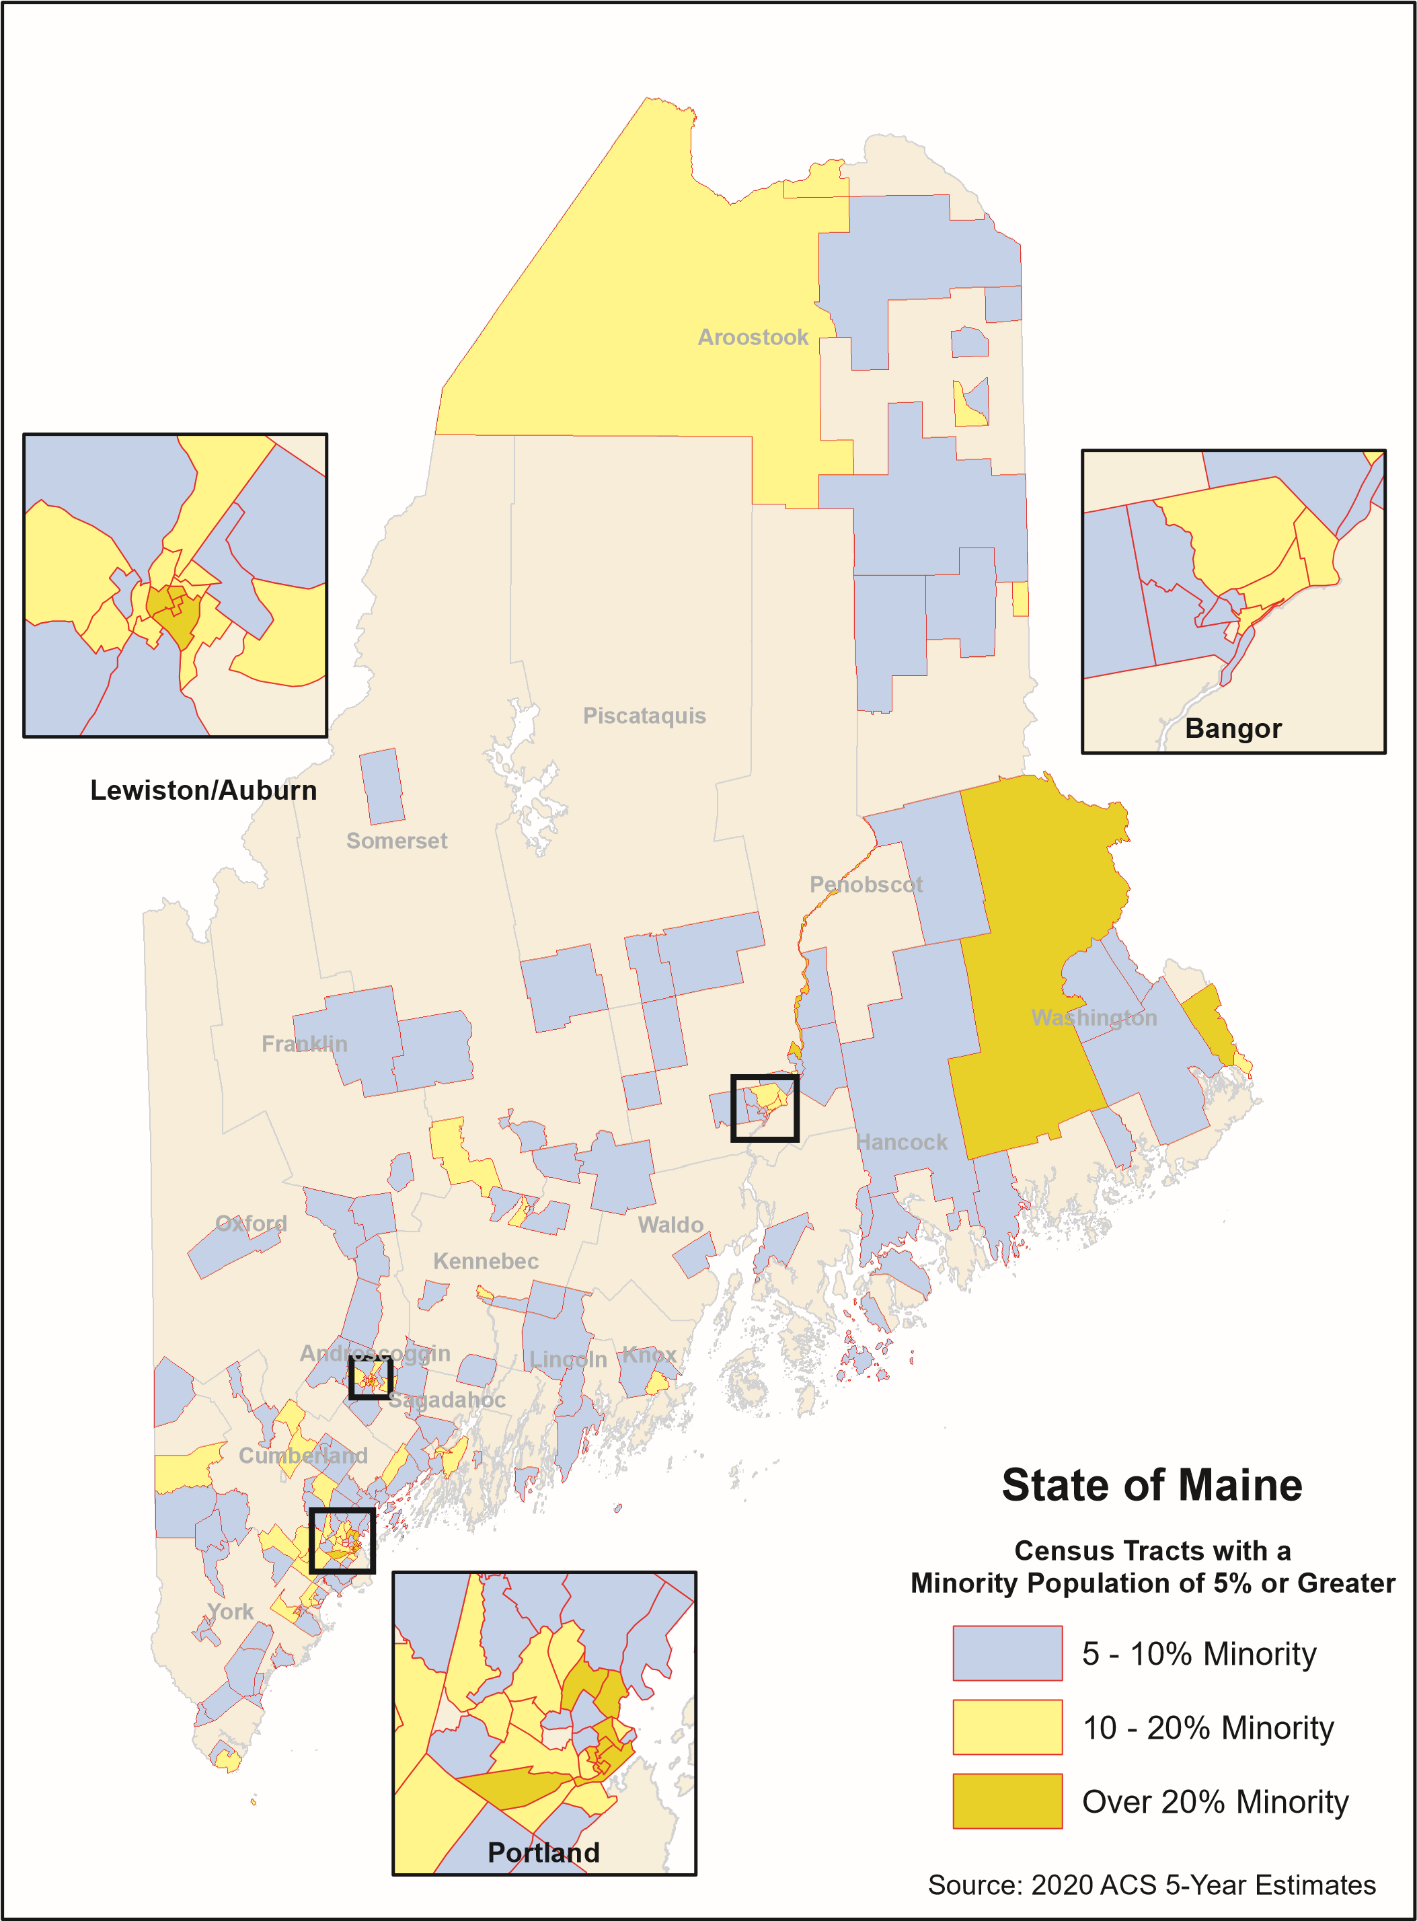

Non-American National Origin

The map representing data on the national origin of Maine residents is similar in many ways to the map of minorities. The core of Cumberland County again has the highest percentage of non-American born persons. The St. John Valley of northernmost Aroostook County several towns with large numbers of non-native born residents. Towns in this area along the border with Canada show up more prominently on this map than the minorities map, reflecting a higher representation of French Canadians. The map of concentrations of non-American born residents shows many of these border towns with percentages higher than the state average though most of these towns are sparsely populated. Cumberland and Androscoggin Counties have concentrations of non-native born people due to the Maine Refugee Resettlement Program centered in Portland (Cumberland County) and Lewiston (Androscoggin County). There are relatively few towns in the western and eastern areas of the state with concentrations of non-natives, other than clusters around Augusta and Bangor.

County | Total  Population | Native Born  # | Native Born  % | Foreign Born  %
Maine | 1,340,825 | 1,292,686 | 96.41% | 3.59%
Androscoggin | 107,958 | 104,163 | 96.48% | 3.51%
Aroostook | 67,431 | 64,730 | 95.99% | 4.01%
Cumberland | 294,520 | 276,817 | 93.99% | 6.01%
Franklin | 29,933 | 29,395 | 98.20% | 1.80%
Hancock | 54,832 | 53,042 | 96.74% | 3.26%
Kennebec | 122,158 | 119,375 | 97.72% | 2.28%
Knox | 39,809 | 38,778 | 97.41% | 2.59%
Lincoln | 34,415 | 33,600 | 97.63% | 2.37%
Oxford | 57,741 | 56,815 | 98.40% | 1.60%
Penobscot | 151,696 | 147,351 | 97.14% | 2.86%
Piscataquis | 16,864 | 16,515 | 97.93% | 2.07%
Sagadahoc | 35,720 | 34,484 | 96.54% | 3.46%
Somerset | 50,573 | 49,703 | 98.28% | 1.72%
Waldo | 39,723 | 38,872 | 97.86% | 2.14%
Washington | 31,378 | 30,202 | 96.25% | 3.75%
York | 206,074 | 198,844 | 96.49% | 3.51%

The map on the following page identifies Non-American National Origin populations by county.

Aroostook

Piscataquis
Somerset

Penobscot

Franklin
Washington

Oxford

Kennebec

Waldo

Hancock

Androscoggin Knox

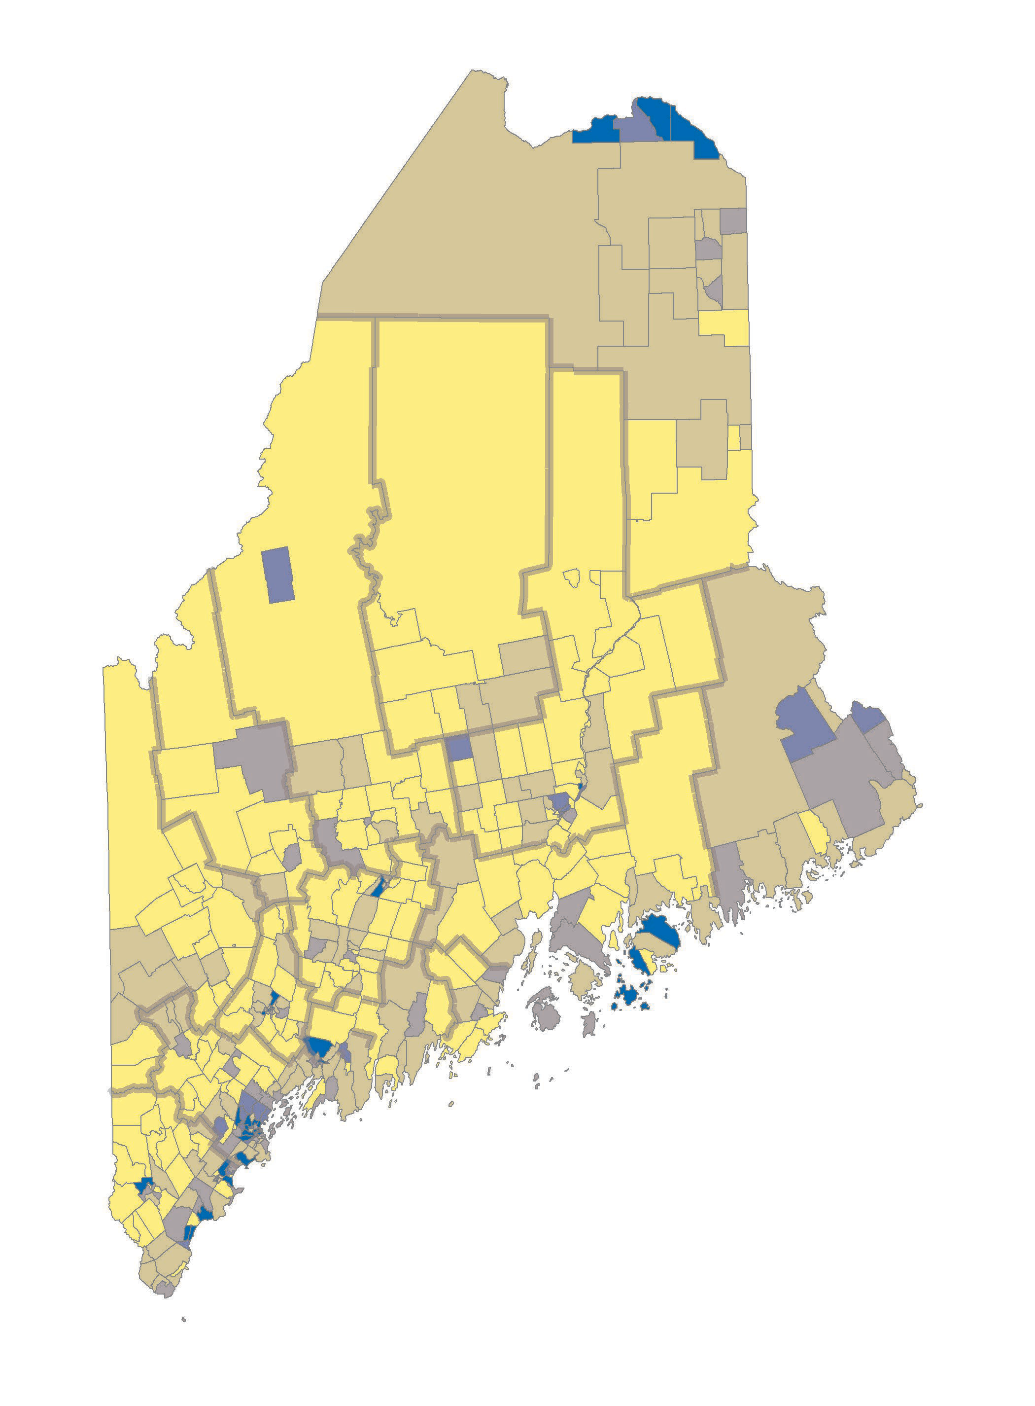

Cumberland

York

Sagadahoc

Lincoln

State of Maine
Census Tracts
Percent of Population Born Outside U.S.
Percent Foreign Born
Less than 2%
2 - 4%
4 - 6%
6 - 8%
8% or Greater
Source: 2020 ACS 5-Year Estimates

TITLE VI TRAINING

Internal

MaineDOT requires periodic Title VI Program training to include the following office and bureaus: Project Development (including Multimodal Program, Property Office, Highway and Bridge), Planning, Safety Office, Environment and Maintenance and Operations. The Civil Rights Office has requested such comprehensive training from FHWA’s Resource Center but this has not yet been available. In addition, upon the promotion or reassignment of any of these positions, the Title VI Coordinator will request to meet with that individual to conduct training to familiarize the employee with the Title VI obligations related to his/her program area as well as the best practices for carrying out those requirements. The Title VI Coordinator will schedule Title VI related training to address regulatory changes, as appropriate.

Staff who desire additional training may request it directly from the Title VI Coordinator. The Title VI Coordinator will meet with and update MaineDOT management at least once annually on any issue identified through annual reviews or updates in federal requirements or program changes.

The Title VI Coordinator will meet semi-annually with the Title VI Liaisons as a group to discuss any program issues or concerns that they wish to bring forward or any issues identified in annual reviews or program changes.

The Title VI Coordinator will meet individually as needed with Title VI Liaisons to discuss progress and any concerns or ideas that the Liaisons may generate.

External

MaineDOT will provide opportunities for training to any Subrecipient. Any time MaineDOT, FHWA or any agency of the USDOT offers training sessions, MaineDOT will extend the training opportunity to our Subrecipients. These include FHWA webinars and local training opportunities that may be provided as requested by MaineDOT.

MaineDOT also provides an open invitation to Subrecipients for Title VI training or to speak about changes and requirements, and the Civil Rights Office will make itself available to attend association meetings and other meeting to provide information, either formal or informal, on Title VI requirements.

The Civil Rights Office provides training on Title VI requirements, Disadvantaged Business Enterprise (DBE) recruiting and reporting, and Davis Bacon labor compliance reporting, twice annually to LPAs and their consultants. Approximately 50 to 60 LPA officials and consultants attend each session, and in order for an LPA to become and remain certified by MaineDOT, the LPA must attend the training every three years. In addition, the Civil Rights Office provides annual training to MaineDOT construction residents, program managers, project development staff and contractors regarding documentation requirements related to Title VI, On-the-Job Training, DBE, and Davis

Bacon compliance. The documentation training is mandatory and is usually attended by approximately 200 staff.

COMPLAINT PROCEDURES

Who can file? Any person who believes they-or with a specific class of persons-were subjected to discrimination on the basis of race, color or national origin in the programs and activities of a federal-aid recipient may file a Title VI complaint.

Where can one file? Complaints may be filed with MaineDOT, FHWA Division Offices, the FHWA Office of Civil Rights, the United States Department of Transportation (USDOT) Departmental Office of Civil Rights, or the United States Department of Justice.

When must one file? According to U.S. DOT regulations (49 CFR §21.11(b)), a complaint must be filed not later than 180 days after the alleged discrimination.

What should a complaint look like? Complaints should be in writing and signed and may be filed by mail, fax, in person, or email. In the alternative, the complainant may call the Civil Rights Office to report the allegations by telephone, and the Civil Rights Office will transcribe the allegations of the complaint as provided over the telephone. The Civil Rights Office will then send the written complaint as provided by telephone to the complainant for correction and signature. A written complaint should contain at least the following information:

  - A written description of what happened;
  - A way to contact the complainant which must include telephone number, e-mail address and physical address;
  - The basis of the complaint (i.e., race, color, national origin);
  - The identification of a specific person(s) and the respondent (i.e., agency/organization/contractor) alleged to have discriminated;
  - Sufficient information to understand the facts that led the complainant(s) to believe that discrimination occurred in a program or activity that received Federal financial assistance; and
  - The date(s) of the alleged discriminatory act(s). Complainant should indicate if the alleged discrimination is on-going.

How are complaints routed? FHWA is responsible for all decisions regarding whether a complaint should be accepted, dismissed, or referred to another agency.
With this understanding, complaints should be routed in the following manner:

  - All complaints will be routed to the FHWA Headquarters Office of Civil Rights (HCR). HCR is responsible for all decisions whether to accept, dismiss or transfer Title VI complaints filed against State DOTs or subrecipients of federal financial assistance.

  - Complaints should be forwarded from the initial receiving agency through the federal-aid highway oversight hierarchy until the complaint reaches HCR. For example, if a complaint is received by a subrecipient City, the City should forward the complaint to the State DOT, which will forward the complaint to the State’s FHWA Division Office, which will then forward the complaint to HCR.
  - State DOTs and subrecipients must log all complaints received.
  - HCR decides on whether to accept, dismiss or transfer the complaint. HCR will notify the complainant, the FHWA Division Office, State DOT and subrecipient (where applicable).

Complaints may be sent to:

and/or
Civil Rights Office
Maine Department of Transportation 16 State House Station
Augusta, ME 04333-0016 Attention: Sherry Y. Tompkins Tel. 207-624-3066
Fax: 207-624-3021
E-mail: sherry.tompkins@maine.gov

Federal Highway Administration Region 1 Office
Edmund S. Muskie Federal Building
ATTN: Wanda Hughley-Culbertson, Civil Rights Specialist 40 Western Ave., Room 614
Augusta, ME 04330
Tel. 207-512-4912
Fax: 207-626-9133
E-mail: wanda.hughley-culbertson@dot.gov

and/or

Wanda Hughley-Culbertson, Civil Rights Specialist Maine and New Hampshire Divisions
Federal Highway Administration 53 Pleasant St., Suite 2200
Concord, NH 03301
Tel. 603-410-4860
Fax: 603-238-2829
E-mail: wanda.hughley-culbertson@dot.gov

and/or

Federal Highway Administration Headquarters – Office of Civil Rights 1200 New Jersey Ave., SE HCR-40, Room 81-101
Washington, DC 20590
Tel. 202-366-0693
Fax: 202-366-1599
Additionally, complaints may be filed at the U.S. Department of Justice at: Federal Coordination and Compliance Section – NWB
Civil Rights Division
950 Pennsylvania Ave. NW Washington, DC 20530

What are the potential outcomes for processing a complaint? There are four potential outcomes for processing complaints:

- Accept: If a complaint is timely (see Section VII, 3rd paragraph, above), contains sufficient information to support a claim under Title VI, and concerns matters under FHWA’s jurisdiction, the HCR will send to the complainant, the respondent agency, and the FHWA Division Office a written notice that it has accepted the complaint for investigation.

- Preliminary review: If it is unclear whether the complaint allegations are sufficient to support a claim under Title VI, then HCR may: 1) dismiss the claim; or 2) engage in a preliminary review to acquire additional information from the complainant and/or respondent before deciding whether to accept, dismiss, or refer the complaint.

- Procedural dismissal: If a complaint is not filed timely, is not in writing and signed, or features other procedural/practical defects, then HCR will send the complainant, respondent, and Division Office a written notice that it is dismissing the complaint.

- Referral/Dismissal: If the complaint is procedurally sufficient but FHWA 1) lacks jurisdiction over the subject matter; or 2) lacks jurisdiction over the respondent entity, then HCR will either dismiss the complaint or refer it to another agency that does have jurisdiction. If HCR dismisses the complaint, it will send the complainant, respondent, and FHWA Division Office a copy of the dismissal notice. For referrals, FHWA will send a written referral notice with a copy of the complaint to the proper Federal agency and a copy to the USDOT Departmental Office of Civil Rights.

All Letters of Finding issued by FHWA are final.

What are the timeframes for investigations? For FHWA, there is no regulatory timeframe for completing investigations; however, FHWA strives to complete all tasks within 180 days from the date of acceptance. For complaints that have been delegated to

MaineDOT by FHWA, 23 CFR §200.9(b)(3) provides that State DOTs must complete investigations within 60 days of receipt of the delegated complaint from FHWA.

Investigation files are confidential and will be maintained by MaineDOT. The contents of such files will only be disclosed to appropriate MaineDOT personnel and federal authorities in accordance with federal and state laws. MaineDOT will retain files in accordance with records retention schedules and all federal guidelines.

See Appendix I for MaineDOT’s Title VI complaint form. It may also be found at: https://www.maine.gov/mdot/civilrights/title-vi/.

DISSEMINATION OF TITLE VI INFORMATION

Public Participation

Planning (23 CFR 450.210(a) & 23 CFR 450.316(1)), Environment (National Environmental Policy Act of 1969), Property (Uniform Relocation Assistance and Real Property Acquisition Policies Act of 1970, as amended) and Design (23 USC 109(h)) require effective public involvement/public participation processes, which are combined into MaineDOT’s Public Involvement in Transportation Decision Making, found at https://www.maine.gov/mdot/planning/docs/2021/pip0321.pdf. Highlights from the plan are as follows:

Public Involvement and Traditionally Underserved Populations

Many people in minority and low-income communities, as well as those with low literacy and/or limited English proficiency, have traditionally been underserved by conventional outreach methods. Reaching out to traditionally underserved groups help ensure that all customers and stakeholders have opportunities to influence the decision-making process. It sets the tone for subsequent project activities and promotes a spirit of inclusion. MaineDOT meeting planners strive to encourage attendance among groups protected by anti-discrimination laws with which MaineDOT is required to comply. This tailoring of outreach efforts is particularly useful because the efforts:

  - Provides fresh perspectives to project planners and developers.
  - Gives MaineDOT information about community-specific issues and concerns.
  - Allows MaineDOT to identify potential conflicts.
  - Allows feedback on how to get underserved communities involved.
  - Increases the likelihood that solutions ultimately selected are those which best meet the needs of these communities.

To maximize the effectiveness of the Department’s public participation efforts in engaging underserved populations, MaineDOT staff is committed to:

  - Planning public meetings and hearings well in advance and publicizing them in diverse media, flyers and on the MaineDOT website.

  - Ensuring that meeting notices state that the meeting uses accessible-format materials.
  - Determining the existence of non-English languages and other cultural characteristics that could inhibit public participation and offering appropriate accommodations to reduce any barriers.
  - Accepting both verbal and written comments in languages other than English.
  - Holding meetings and conducting outreach in the affected neighborhoods, using community centers as meeting locations and venues for informal outreach.
  - Using varied meeting times and locations to accommodate the schedule, transportation, and child-care limitations of community members.
  - Holding meetings at convenient locations that are accessible and welcoming to all, including those with disabilities. This includes providing appropriate room set-up and, when requested, alternate formats of handouts (e.g., large-print materials) and audio equipment.
  - Making available alternative methods for two-way flow of information and input between MaineDOT and people who are not likely to attend meetings.
  - Using various illustration and visualization techniques to convey the project information including, but not limited to, charts, graphs, photos, maps, and the Internet.
  - Reaching out to others, both internally and externally, with expertise in contacting and connecting with underserved populations to obtain advice and information about best practices and effective techniques.

Public Notice

MaineDOT posts a “Notice to the Public” on bulletin boards and in public places at its Maine office and regional facilities. The Notice is also posted on the MaineDOT website at http://www.maine.gov/mdot/civilrights/title-vi and is titled “Non-Discrimination/Title VI Poster”. The Public Notice is attached as Appendix J.

In addition, a copy of MaineDOT’s Civil Rights brochure, “Know Your Rights” is made available at all public meetings conducted by MaineDOT and can be made available in other languages for the benefit of LEP populations on request. A copy of the brochure is attached as Appendix K.

Notification to Beneficiaries – Website

MaineDOT’s website is designed to ensure Title VI information is readily accessible to the public. The website informs the public of their rights under Title VI and provides information on how to file a complaint. Title VI information available on MaineDOT’s website includes:

  - MaineDOT’s Title VI Implementation Plan
  - 2020 Demographic Profile of Maine (to be updated as demographic information becomes available)
  - How to File a Discrimination Complaint

  - Complaint Form
  - Foreign Language Interpretation Information
  - Language Identification Card
  - Minority and Outreach Contact Information
  - Title VI Public Participation Template for Subrecipients
  - Title VI brochure – Know Your Rights
  - Nondiscrimination/Title VI Poster
  - Minority Populations by County – charts and maps
  - FHWA Subrecipient Guide
  - 2022 Title VI Assurances
  - Form 1273 for construction contracts

REVIEW OF MAINEDOT DIRECTIVES

The Director of the Civil Rights Office receives and reviews all draft Administrative Policy Memoranda for compliance with federal civil rights laws and regulations. If a memorandum is believed to have Title VI implications, it will be discussed with the Commissioner and modified as necessary.

COMPLIANCE AND ENFORCEMENT PROCEDURE

Noncompliance Procedure Specified in 23 CFR §200.9

In the event MaineDOT determines, after the completion of a pre-award or post-award desk audit review, compliance review or complaint investigation (collectively, the “Review”), that a Subrecipient is not in compliance with Title VI requirements, MaineDOT will notify the Subrecipient in writing, meet and coordinate with the Subrecipient to develop remedial action to promptly resolve the deficiency(ies), and prepare a written plan of such remedial action, all within 90 days of MaineDOT’s original determination.

Remedial Action

Subrecipients found not to be in compliance are expected to correct all deficiencies according to the remedial action plan prepared by MaineDOT. The Title VI Coordinator will provide technical assistance and work with the Subrecipient to ensure implementation of the remedial action plan. When the Title VI Coordinator has determined that a Subrecipient’s deficiencies are sufficiently corrected, the Subrecipient will be notified that the review process is complete. MaineDOT will send an official Closeout Letter to the Subrecipient.

Effecting Compliance

When a Subrecipient fails to take appropriate action to make corrective action(s) to resolve the deficiency(ies) cited in the Review:

- The Subrecipient moves from a “deficiency status” to non-compliance;
- MaineDOT will submit a copy of the case file to FHWA with a recommendation that the Subrecipient be found in noncompliance; and/or
- MaineDOT may, with the concurrence of FHWA (or other USDOT oversight agency), initiate proceedings to impose sanctions for non-compliance.

LIMITED ENGLISH PROFICIENCY (Language Access Plan)

MaineDOT undertakes an extensive Four Factor Analysis every three years. That most recent analysis was done in 2020. That analysis showed that there are five populations that exceed the 1,000/5% threshold for Limited English Proficient (LEP) persons: French (including Patois, Cajun), Spanish or Spanish Creole, Chinese, Arabic and African languages.

Each Program area is responsible for determining which personnel will interact with members of the public and will have access to and an understanding of LEP population in the respective area. The 2020 Four Factor Analysis showed the following:

French. There are 7,154 French-speaking LEP persons in Maine. The 2018 ACS County data shows the greatest concentration of French-speaking LEPs are in Androscoggin County (1,256 persons), Aroostook County (1,799) and Cumberland County (1,217. Again, the available data indicate that French- speaking LEP persons are dispersed throughout Maine, rather than concentrated in communities, although there are populations of French-speaking LEP persons in Portland, Lewiston/Auburn and in the St. John Valley of Aroostook County.

Spanish or Spanish Creole. There are 2,519 Spanish or Spanish Creole LEP persons in Maine. The 2018ACS County data indicates that that the largest concentrations of Spanish or Spanish Creole LEP persons appear to be in, Cumberland County (1,859), York County (282) and Washington County (238). The available data would indicate that Spanish-speaking LEP persons are dispersed throughout Maine, rather than concentrated in communities, although the Cumberland County numbers would suggest that there are likely a substantial number in the City of Portland. In addition, there is a Spanish-speaking community in Washington County.

Chinese. There are 1,467, Chinese-speaking LEP persons in Maine. The ACS County data shows that the greatest concentration of Chinese LEP are in Cumberland County (414 persons), Penobscot County (201), and Kennebec County (342). The available data indicate that Chinese LEP persons are dispersed throughout Maine, rather than concentrated in communities. There are, however, large areas of Maine where there are no Chinese LEP persons.

Arabic. The are 1,238 Arabic LEP persons in Maine. The ACS County data shows that the greatest concentrations of Arabic LEP are in Cumberland County (857 persons), and York County (226). The available data indicate that the Arabic LEP populations are dispersed throughout Maine, rather than concentrated in

communities, although the Cumberland number suggest that there are a substantial number in the Portland area. Similar to Chinese LEP populations, however, there are large areas of Maine where there are no Arabic LEP persons.

African Languages. The are 1,164 LEP speakers who fall under the ACS classification “Amharic, Somali or other Afro-Asiatic languages” in Maine. Since this is a vague grouping at best, we presume that the re-settlement communities of metropolitan Lewiston/Auburn and Portland contain substantial numbers of Somali people who speak African languages, with the remainder of speakers dispersed throughout Maine.

MaineDOT monitors new data to ensure that, if thresholds are exceeded in non-English language populations, processes will be put into place to address any language discrimination that may exist. Given the increase in the LEP populations discussed above, MaineDOT will need to ensure, at a minimum, provision of appropriate translation efforts, particularly in terms of public outreach and the provision of vital documents that are available in languages spoken by the five groups. MaineDOT’s 2020 Four Factor Analysis and information on translation and diversity services by county can be found on our website at: https://www.maine.gov/mdot/civilrights/title-vi/.

The United States Department of Transportation (USDOT)
Standard Title VI/ Nondiscrimination Assurances
DOT Order No. 1050.2A

The Maine Department of Transportation (herein referred to as the "Recipient") HEREBY AGREES THAT, as a condition of receiving any Federal financial assistance from the U.S. Depmiment of Transportation (USDOT) through the Fedeml Highway Administmtion (FHWA), is subject to and will comply with the following:

Statutory/Regulatory Authorities

- Title VI of the Civil Rights Act of 1964 (42 U.S.C. §2000d et seq., 78 stat. 252), which prohibits discrimination based on race, color, national origin;
- 49 C.F.R. Pmi 21 (entitled Non-discrimination in Federally-Assisted Programs of the Department a/Transportation - Effectuation a/Title VI a/The Civil Rights Act of 1964);
- 28 C.F.R. section 50.3 (U.S. Depmiment of Justice Guidelines for Enforcement of Title VI of the Civil Rights Act of 1964);

The preceding statutmy and regulatory cites hereinafter are referred to as the "Acts" and "Regulations" respectively.

General Assurances

In accordance with the Acts, the Regulations, and other pertinent directives, circulars, policy, memoranda, and/or guidance, the Recipient hereby gives assurance that it will promptly take any measures necessmy to assure that:

"No person in the United States shall, on the grounds of race, color, or national origin, be excluded from participation in, be denied the benefits of, or be otherwise subjected to discrimination under any program or activity for which the Recipient receives Federal financial assistance from DOT, including the FHWA. "

The Civil Rights Restoration Act of 1987 clarified the original intent of Congress, with respect to Title VI and other non-discrimination requirements (the Age Discrimination Act of 1975, and Section 504 of the Rehabilitation Act of 1973) by restoring the broad, institutional-wide scope and coverage of these non­ discrimination statutes and requirements to include all programs and activities of the Recipient, so long as any portion of the program is Federally assisted.

Specific Assurances

More specifically, and without limiting the above general Assurance, the Recipient agrees with and gives the following Assurances with respect to its federally assisted Highway Program:

- The Recipient agrees that each "activity," "facility," or "program," as defined in§§ 21.23 (b) and
21.23 (e) of 49 C.F.R. § 21 will be (regarding an "activity") facilitated, or will be (with regard to a "facility") operated, or will be (with regard to a "program") conducted in compliance with all

requirements imposed by, or pursuant to the Acts and the Regulations.

- The Recipient will insert the following notification in all solicitations for bids, Requests For Proposals for work, or material subject to the Acts and the Regulations made in connection with all Federal Aid Highway Program activities and, in adapted form, in all proposals for negotiated agreements regardless of funding source:

"The Maine Department of Transportation, in accordance with the provisions of Title VI of the Civil Rights Act of 1964 (78 Stat. 252, 42 US. C. §§ 2000d to 2000d-4) and the Regulations, hereby not/fies all bidders that it will affirmatively assure that any contract entered into pursuant to this advertisement, disadvantaged business enterprises will be afforded full and fair opportunity to submit bids in response to this invitation and will not be discriminated against on the grounds of race, color, or national origin in consideration for an award."

- The Recipient will insert the clauses of Appendix A and E of this Assurance in every contract or agreement subject to the Acts and the Regulations.

- The Recipient will insert the clauses of Appendix C of this Assurance, as a covenant running with the land, in any deed from the United States effecting or recording a transfer ofreal property, structures, use, or improvements thereon or interest therein to a Recipient.

- That where the Recipient receives Federal financial assistance to construct a facility, or pmi of a facility, the Assurance will extend to the entire facility and facilities operated in connection therewith.

- That where the Recipient receives Federal financial assistance in the f01m, or for the acquisition of real property or an interest in real prope1iy, the Assurance will extend to rights to space on, over, or under such property.

- That the Recipient will include the clauses set forth in Appendix Band Appendix D of this Assurance, as a covenant running with the land, in any future deeds, leases, licenses, permits, or similar instruments entered into by the Recipient with other parties:

  - for the subsequent transfer of real prope1iy acquired or improved under the applicable activity, project, or program; and
  - for the construction or use of, or access to, space on, over, or under real prope1iy acquired
or improved under the applicable activity, project, or program.

- That this Assurance obligates the Recipient for the period during which Federal financial assistance is extended to the progrmn, except where the Federal financial assistance is to provide, or is in the form of, personal property, or real property, or interest therein, or structures or improvements thereon, in which case the Assurance obligates the Recipient, or any transferee for the longer of the following periods:

  - the period during which the property is used for a purpose for which the Federal financial assistance is extended, or for another purpose involving the provision of similar services or benefits; or

  - the period during which the Recipient retains ownership or possession of the property.

- The Recipient will provide for such methods of administration for the program as are found by the Secretaiy of Transp011ation or the official to whom he/she delegates specific authority to give reasonable guarantee that it, other recipients, sub-recipients, sub-grantees, contractors, subcontractors, consultants, transferees, successors in interest, and other pa11icipants of Federal financial assistance under such program will comply with all requirements imposed or pursuant to the Acts, the Regulations, and this Assurance.

- The Recipient agrees that the United States has a right to seek judicial enforcement regarding any matter arising under the Acts, the Regulations, and this Assurance.

By signing this ASSURANCE, the Maine Department of Tmnsportation also agrees to comply (and require any sub-recipients, sub-grantees, contractors, successors, transferees, and/or assignees to comply) with all applicable provisions governing the FHWA and USDOT access to records, accounts, documents, information, facilities, and staff. You also recognize that you must comply with any program or compliance reviews, and/or complaint investigations conducted by the FHWA and USDOT. You must keep records, reports, and submit the material for review upon request to the FHWA and USDOT, or its designee, in a timely, complete, and accurate way. Additionally, you must comply with all other repo11ing, data collection, and evaluation requirements, as prescribed by law or detailed in program guidance.

The Maine Department of Transportation gives this ASSURANCE in consideration of and for obtaining any Federal grants, loans, contracts, agreements, property, and/or discounts, or other Federal-aid and Federal financial assistance extended after the date hereof to the recipients by the U.S. Department of Transpo11ation under the Federal Aid Highway Progmm. This ASSURANCE is binding on the State of Maine, other recipients, sub-recipients, sub-grantees, contractors, subcontractors and their subcontractors', transferees, successors in interest, and any other participants in the Federal Aid Highway Program. The person(s) signing below is authorized to sign this ASSURANCE on behalf of the Recipient.

Maine Department of Transportation

By----- ,,._. _,,,
Bruce A. Van Note, Commissioner

Dated --'C.. --=-- c+-- .:z -2 0 2= 2... --

Encl.: Appendices A, B, C, D and E

APPENDIX A

Performance Requirements

During the performance of this contract, the contractor, for itself, its assignees, and successors in interest (hereinafter referred to as the "contractor") agrees as follows:

- Compliance with Regulations: The contractor (hereinafter includes consultants) will comply with the Acts and the Regulations relative to Non-discrimination in Federally-assisted programs of the
U.S. Department of Transportation, Federal HiglnvayAdministration (FHWA), as they may be amended from time to time, which are herein incorporated by reference and made a part of this contract.

- Non-discrimination: The contractor, with regard to the work performed by it during the contract, will not discriminate on the grounds of race, color, or national origin in the selection and retention of subcontractors, including procurements of materials and leases of equipment. The contractor will not pmticipate directly or indirectly in the discrimination prohibited by the Acts and the Regulations, including employment practices when the contract covers any activity, project, or program set fo1th in Appendix B of 49 CFR Part 21.

- Solicitations for Subcontracts, Including Procurements of Materials and Equipment: In all solicitations, either by competitive bidding, or negotiation made by the contractor for work to be performed under a subcontract, including procurements of materials, or leases of equipment, each potential subcontractor or supplier will be notified by the contractor of the contractor's obligations under this contract and the Acts and the Regulations relative to Non-discrimination on the grounds ofrace, color, or national origin.

- Information and Reports: The contractor will provide all information and reports required by the Acts, the Regulations, and directives issued pursuant thereto and will permit access to its books, records, accounts, other sources of info1mation, and its facilities as may be determined by the Recipient or the FHWA to be pe1tinent to ascertain compliance with such Acts, Regulations, and instructions. Where any information required of a contractor is in the exclusive possession of another who fails or refuses to furnish the information, the contractor will so certify to the Recipient or the FHWA, as appropriate, at1d will set forth what effo1ts it has made to obtain the information.

- Sanctions for Noncompliance: In the event of a contractor's noncompliance with the Non­ discrimination provisions of this contract, the Recipient will impose such contract sanctions as it or the FHWA may determine to be appropriate, including, but not limited to:

  - withholding payments to the contractor under the contract until the contractor complies; and/or
  - cancelling, terminating, or suspending a contract, in whole or in part.

- Incorporation of Provisions: The contractor will include the provisions of paragraphs one through six in every subcontract, including procurements of materials and leases of equipment, unless exempt by the Acts, the Regulations and directives issued pursuant thereto, the contractor will take action with respect to any subcontract or procurement as the Recipient or the FHWA may direct as

a means of enforcing such provisions including sanctions for noncompliance. Provided, that if the contractor becomes involved in, or is threatened with litigation by a subcontractor, or supplier because of such direction, the contractor may request the Recipient to enter into any litigation to protect the interests of the Recipient. In addition, the contractor may request the United States to enter into the litigation to protect the interests of the United States.

APPENDIXB

CLAUSES FOR DEEDS TRANSFERRING UNITED STATES PROPERTY

The following clauses will be included in deeds effecting or recording the transfer ofreal property, structures, or improvements thereon, or granting interest therein from the United States pursuant to the provisions of Assurance 4:

NOW, THEREFORE, the U.S. Department of Transportation as authorized by law and upon the condition that the Maine Department of Transportation will accept title to the lands and maintain the project constructed thereon in accordance with 49 U.S. Code §5334, the Regulations for the Administration of the Federal Aid Highway Program, and the policies and procedures prescribed by the FHWA of the U.S. Department ofTransp01iation in accordance and in compliance with all requirements imposed by Title 49, Code of Federal Regulations, U.S. Department of Transportation, Subtitle A, Office of the Secretaty, Part 21, Non-discrimination in Federally-assisted programs of the U.S Depatiment of Transp01iation pertaining to and effectuating the provisions of Title VI of the Civil Rights Act of 1964 (78 Stat. 252; 42 U.S.C. § 2000d to 2000d-4), does hereby remise, release, quitclaim and convey unto the Maine Department of Transportation all the right, title and interest of the U.S. Department of Transp01iation in and to said lands described in Exhibit A attached hereto and made a part hereof.

(HABENDUM CLAUSE)

TO HAVE AND TO HOLD said lands and interests therein unto Maine Department of Transportation and its successors forever, subject, however, to the covenants, conditions, restrictions and reservations herein contained as follows, which will remain in effect for the period during which the real prope1iy or structures are used for a purpose for which Federal financial assistance is extended or for another purpose involving the provision of similar services or benefits and will be binding on the Maine Department of Transportation, its successors and assigns.

The Maine Department of Transportation, in consideration of the conveyance of said lands and interests in lands, does hereby covenant and agree as a covenant running with the land for itself, its successors and assigns, that(!) no person will on the grounds ofrace, color, or national origin, be excluded from participation in, be denied the benefits of, or be otherwise subjected to discrimination with regard to any facility located wholly or in part on, over, or under such lands hereby conveyed [,] [and]* (2) that the Maine Department of Transportation will use the lands and interests in lands and interests in lands so conveyed, in compliance with all requirements imposed by or pursuant to Title 49, Code of Federal Regulations, US. Department of Transportation, Subtitle A, Office of the Secretary, Pati 21, Nondiscrimination in Federally-assisted programs of the U.S. Department of Transportation, Effectuation of Title VI of the Civil Rights Act of 1964, and as said Regulations and Acts may be amended [i and (3) that in the event of breach of any of the above-mentioned non-discrimination conditions, the Depatiment will have a right to enter or re-enter said lands and facilities on said land, and that above described land and facilities will thereon reve1i to and vest in and become the absolute property of the U.S. Depaiiment of Transpo1iation and its assigns as such interest existed prior to this instruction].*

(*Reverter clause and related language to be used only when it is determined that such a clause is necessary in order to make clear the purpose of Title VI.)

APPENDIXC

CLAUSES FOR TRANSFER OF REAL PROPERTY ACQUIRED OR IMPROVED UNDER THE ACTIVITY, FACILITY, OR PROGRAM

The following clauses will be included in deeds, licenses, leases, permits, or similar instruments entered into by the Maine Department of Transportation pursuant to the provisions of Assurance 7(a):

- The (grantee, lessee, permittee, etc. as appropriate) for himself/herself, his/her heirs, personal representatives, successors in interest, and assigns, as a part of the consideration hereof, does hereby covenant and agree [in the case of deeds and leases add "as a covenant running with the land"] that:

  - In the event facilities are constructed, maintained, or otherwise operated on the property described in this (deed, license, lease, permit, etc.) for a purpose for which a U.S. Depaitment of Transportation activity, facility, or program is extended or for another purpose involving the provision of similar services or benefits, the (grantee, licensee, lessee, permittee, etc.) will maintain and operate such facilities and services in compliance with all requirements imposed by the Acts and Regulations (as may be amended) such that no person on the grounds ofrace, color, or national origin, will be excluded from participation in,
denied the benefits of, or be otherwise subjected to discrimination in the use of said facilities.

- With respect to licenses, leases, permits, etc., in the event of breach of any of the above Non­ discrimination covenants, Maine Department of Transportation will have the right to terminate the (lease, license, permit, etc.) and to enter, re-enter, and repossess said lands and facilities thereon, and hold the same as if the (lease, license, permit, etc.) had never been made or issued.*

- With respect to a deed, in the event of breach of any of the above Non-discrimination covenants, the Maine Department of Transportation will have the right to enter or re-enter the lands and facilities thereon, and the above described lands and facilities will there upon revert to and vest in and become the absolute prope1ty of the Maine Department of Transportation and its assigns.*

(*Reverter clause and related language to be used only when it is determined that such a clause is necessaiy to make clear the purpose of Title VI.)

APPENDIXD

CLAUSES FOR CONSTRUCTION/USE/ACCESS TO REAL PROPERTY ACQUIRED UNDER THE ACTIVITY, FACILITY OR PROGRAM

The following clauses will be included in deeds, licenses, permits, or similar instruments/agreements entered into by the Maine Department of Transportation pursuant to the provisions of Assurance 7(b):

- The (grantee, licensee, permittee, etc., as appropriate) for himself/herself, his/her heirs, personal representatives, successors in interest, and assigns, as a pait of the consideration hereof, does hereby covenant and agree (in the case of deeds and leases add, "as a covenant running with the land") that (I) no person on the ground of race, color, or national origin, will be excluded from participation in, denied the benefits of, or be othe1wise subjected to discrimination in the use of said facilities, (2) that in the construction of any improvements on, over, or under such land, and the furnishing of services thereon, no person on the ground of race, color, or national origin, will be excluded from pa1ticipation in, denied the benefits of, or otherwise be subjected to discrimination, (3) that the (grantee, licensee, lessee, permittee, etc.) will use the premises in compliance with all other requirements imposed by or pursuant to the Acts and Regulations, as amended, set forth in this Assurance.

- With respect to (licenses, leases, permits, etc.), in the event of breach of any of the above Non­ discrimination covenants, the Maine Department of Transportation will have the right to terminate the (license, permit, etc., as appropriate) and to enter or re-enter and repossess said land and the facilities thereon, and hold the same as if said (license, permit, etc., as appropriate) had never been made or issued. *

- With respect to deeds, in the event of breach of any of the above Non-discrimination covenants, the Maine Department of Transportation will there upon revert to and vest in and become the absolute prope1ty of the Maine Department of Transportation and its assigns. *

(*Reverter clause and related language to be used only when it is determined that such a clause IS
necessary to make clear the purpose of Title VI.)

APPENDIXE

During the performance of this contract, the contractor, for itself, its assignees, and successors in interest (hereinafter referred to as the "contractor") agrees to comply with the following non-discrimination statutes and authorities; including but not limited to:

Pertinent Non-Discrimination Authorities:

  - Title VI of the Civil Rights Act of 1964 (42 U.S.C. § 5 2000d et seq., 78 stat. 252), (prohibits discrimination on the basis of race, color, national origin); and 49 CFR Part 21.
  - The Uniform Relocation Assistance and Real Property Acquisition Policies Act of 1970, (42 U.S.C. § 4601), (prohibits unfair treatment of persons displaced or whose property has been acquired because of Federal or Federal-aid programs and projects);
  - Federal-Aid Highway Act of 1973, (23 U.S.C. § 324 et seq.), (prohibits discrimination on the basis of sex);
  - Section 504 of the Rehabilitation Act of 1973, (29 U.S.C. § 794 et seq.), as amended, (prohibits discrimination on the basis of disability); and 49 CFR Part 27;
  - The Age Discrimination Act of 1975, as amended, (42 U.S.C. § 6101 et seq.), (prohibits discrimination on the basis of age);
  - Airpmi and Airway Improvement Act of 1982, (49 USC§ 471, Section 47123), as amended, (prohibits discrimination based on race, creed, color, national origin, or sex);
  - The Civil Rights Restoration Act of 1987, (PL 100-209), (Broadened the scope, coverage and applicability of Title VI of the Civil Rights Act of 1964, The Age Discrimination Act of 1975 and Section 504 of the Rehabilitation Act of 1973, by expanding the definition of the terms "programs or activities" to include all of the programs or activities of the Federal-aid recipients, sub-recipients and contractors, whether such programs or activities are Federally funded or not);
  - Titles II and III of the Americans with Disabilities Act, which prohibit discrimination on the basis of disability in the operation of public entities, public and private transportation systems, places of public accommodation, and certain testing entities (42 U.S.C. §§ 12131 - 12189) as implemented by Department of Transportation regulations at 49 C.F.R. parts 37 and 38;
  - The Federal Aviation Administration's Non-discrimination statute (49 U.S.C. § 47123) (prohibits discrimination on the basis of race, color, national origin, and sex);
  - Executive Order 12898, Federal Actions to Address Environmental Justice in Minority Populations and Low-Income Populations, which ensures Non-discrimination against minority populations by discouraging programs, policies, and activities with dispropmtionately high and adverse human health or environmental effects on minority and low-income populations;
  - Executive Order 13166, Improving Access to Services for Persons with Limited English Proficiency, and resulting agency guidance, national origin discrimination includes discrimination because of Limited English proficiency (LEP). To ensure compliance with Title VI, you must take reasonable steps to ensure that LEP persons have meaningful access to your programs (70 Fed. Reg. at 74087 to 74100);
  - Title IX of the Education Amendments of 1972, as amended, which prohibits you from discriminating because of sex in education programs or activities (20 U.S.C. 1681 et seq.).

ATTACHMENT 1

MAINE DEPARTMENT OF TRANSPORTATION NONDISCRIMINATION POLICY STATEMENT

TITLE VI (FHWA)

The Maine Department of Transportation is committed to ensuring that the fundamental principles of equal opportunity are upheld in all decisions involving our employees and contractors/consultants, and to ensuring that the public-at-large is afforded access to our programs and services.

In accordance with Title VI of the Civil Rights Act of 1964, no person shall be excluded from participation in, be denied the benefits of, or be otherwise subjected to discrimination under any Maine Depa11ment of Transportation program or activity on the grounds of race, color, or national origin. The Maine Depaitment of Transportation assures all its programs and activities will be free from discrimination, whether those programs or activities are federally assisted or not.

The Maine Depaitment of Transportation conducts its Title VI/Environmental Justice Program in a team approach involving personnel from all program areas, with guidance from within the Civil Rights Office to serve as the Title VI/Environmental Justice Specialist, to ensure the Maine Depaitment ofTransp01tation's compliance with Title VI/Environmental Justice implementing regulations.

Inquiries concerning the Maine Depaitment of Transportation's policies, investigations, complaints, compliance with appJicable laws and regulations, and concerns regarding compliance with Title VI/Environmental Justice may be directed to:

Sherry Y. Tompkins, Director, Civil Rights Office Maine Department of Transp01tatio11
16 State House Station Augusta, ME 04333-0016
Telephone (207) 624-3066
TTY 888-516-9364
sherry.tompkins@maine.gov

This Policy Statement must be circulated throughout the Maine Depaitment of Transpo1tation and be included by reference in all contracts, agreements, programs and services administered by the Department of Transportation.

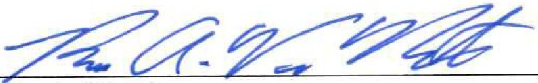
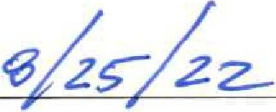
Dated:
Bruce A. Van Note, Commissioner Maine Depaitment of Transp01tation

ATTACHMENT 2

FEDERAL HIGHWAY ADMINISTRATION CIVIL RIGHTS ASSURANCE

The Maine Department of Transportation HEREBY CERTIFIES THAT, as a condition of receiving Federal financial assistance under the Federal Transit Act of 1964, as amended, it will ensure that:

- No person on the basis of race, color or national origin will be subjected to discrimination in the level and quality of transportation services and transportation-related benefits.

- The Maine Department of Transportation will compile, maintain, and submit in a timely manner Title VI information required in compliance with the Department of Transpmiation's Title VI regulation, 49 CFR Pait 21.9.

- The Maine Depmiment of Transpmiation will make it known to the public that those person or persons alleging discrimination on the basis of race, color or national origin as it relates to the provision of transp01iation services and transp01iation-related benefits may file a complaint with the Federal Highway Administration and/or the U.S. Depaiiment of Transportation.

The person or persons whose signature appears below is authorized to sign this assurance on behalf of the grant applicant or recipient.

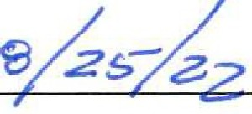
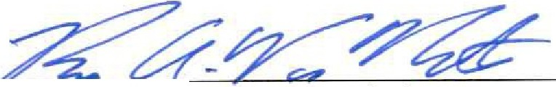DATE:
B'fuceA.VanNote,Cossioner Maine Depaiiment of Transp01iation

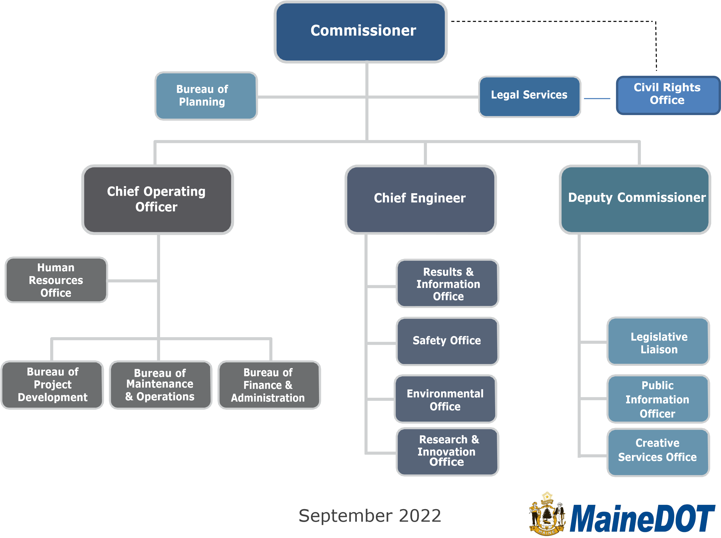
ATTACHMENT 3

MaineDOT Organizational Structure

APPENDIX F

SAMPLE QUESTIONS FOR PROGRAM AREA REVIEWS

QUARTERLY

All Offices:

- Regarding projects, please indicate the relative benefits, services and any adverse impacts and its alternatives on persons and businesses of majority and minority, racial, national origin, and or low-income groups, including but not limited to LEP persons.
  - From planning stage to completion of projects, collect data on all persons involved.
  - A statement of any problems, potential as well as actual, that did, will or may occur with respect to any Title VI Program concern.
- A statement of what action the applicant agrees to or did take to correct any such problems.
- A statement of the affirmative action that the applicant will take to ensure full compliance with all Title VI Program requirements, including, but not limited to, such matters as provisions for communicating with persons whose primary language is not English (LEP), nondiscrimination in covered employment, outreach at all stages of the planning and implementation of the project to persons and communities affected thereby, equal access to services and benefits of the project, and Disadvantaged Business Enterprise participation;
- Now you identified issues, what is your plan of action to ensure full compliance
- A description of how the applicant will or did enforce the Title VI Program requirements of its sub-grantees and contractors
- Any additional analysis necessary

ANNUALLY

Bureau of Planning

- What measures do you take to ensure that a cross-section of people representative of the populations affected by the Department’s projects, including identifying and proactively reaching out to various and diverse social, economic and ethnic groups, participate in the Department’s Public Involvement Process?
- How do you ensure that appropriate accommodations are made for persons with Limited English Proficiency (LEP) (persons who have difficulty speaking, reading, writing and/or understanding English)?
- Were interpreters available when needed to assist with LEP needs?
- How do you collect and analyze statistical data on race, color, and national origin of populations in all areas impacted by the Department’s programs or services?
- Have you received any complaints related to discrimination on the basis of race, color, or national origin? How many and how did you process them?

Bureau of Project Development

- What measures do you take to ensure that a cross-section of people representative of the populations affected by the Department’s projects, including identifying and proactively

reaching out to various and diverse social, economic and ethnic groups, participate in the Department’s Public Involvement Process?
- How do you ensure that appropriate accommodations are made for persons with Limited English Proficiency (LEP) (persons who have difficulty speaking, reading, writing and/or understanding English)?
- Were interpreters available when needed to assist with LEP needs?
- How do you collect and analyze statistical data on race, color, and national origin of populations in all areas impacted by the Department’s programs or services?
- Have you received any complaints related to discrimination on the basis of race, color, or national origin? How many and how did you process them?

Property Office

- How do you ensure that Property Office staff who have direct contact with persons affected by the Department’s acquisition of property needed for projects, comply with Title VI requirements of nondiscrimination on the basis of race, color, or national origin, including compliance with the Uniform Relocation Act of 1970?
- Have you received any complaints related to discrimination on the basis of race, color, or national origin? How many and how did you process them?

Multimodal Program

- How do you ensure that Local Public Agencies (LPA) provide the Department with signed Title VI assurances (Form 1050.2A), including all Appendices, annually?
- How do you ensure that LPAs include in their subcontracts FHWA Form 1273 and Title VI Assurances, including all Appendices?
- Have you received any complaints related to discrimination on the basis of race, color, or national origin? How many and how did you process them?
- How do ensure that public meetings and notices related to LPA projects comply with Title VI?
- Have you received any complaints related to discrimination on the basis of race, color, or national origin? How many and how did you process them?

Bureau of Maintenance and Operations

- How do you ensure that the Bureau’s activities comply with Title VI requirements of nondiscrimination on the basis of race, color, or national origin?
- Have you received any complaints related to discrimination on the basis of race, color, or national origin? How many and how did you handle them?

Environmental Office

- How do you collect and analyze statistical data on race, color, and national origin of populations in all areas impacted by the Department’s programs or services?
- Have you received any complaints related to discrimination on the basis of race, color, or national origin? How many and how did you process them?

Safety Office

- How do you collect and analyze statistical data on race, color, and national origin of populations in all areas impacted by the Department’s programs or services?
- Have you received any complaints related to discrimination on the basis of race, color, or national origin? How many and how did you process them?

APPENDIX G

Subrecipient Reviewed: Date(s) of Desk Audit

Reviewer(s)

- Title VI/Nondiscrimination Policy Statement

- Title VI/Nondiscrimination Assurances

- Name and position of Title VI/Nondiscrimination Coordinator

- Title VI/Nondiscrimination Plan

- Procedures for processing external discrimination complaints

- A list of external discrimination complaints and lawsuits

- Any Accommodations for Limited English Proficient Persons

- Addressing Environmental Justice in minority populations and low-income populations

- Ensuring nondiscrimination in the public participation process

- Collecting and analyzing data to ensure nondiscrimination in programs and activities

- Process for ensuring that solicitations for bid/requests for proposals contain the Title VI/Nondiscrimination Assurance paragraph

- Process for ensuring subcontracts contain the appropriate contract provisions and language from the Title VI Assurances

- Process for Ensuring nondiscrimination in the award of contracts

- Developing a Title VI/Nondiscrimination Annual Work Plan & Accomplishment Report

APPENDIX H
SUB-RECIPIENT TITLE VI COMPLIANCE ASSESSMENT TOOL
23 Code of Federal Regulations (CFR) Part 200.9 (b)(7) requires that the Maine Department of Transportation (MaineDOT) conduct periodic reviews of cities, planning agencies and other recipients of federal-aid highway funds, including locally public agencies, to ensure that they are complying with Title VI of the Civil Rights Act of 1964. Title VI states that “no person in the United States shall be excluded from participation, denied the benefits of, or be subjected to discrimination in any Federally-funded program, policy or activity on the basis of race, color or national origin.”

MaineDOT has developed this assessment as a means of determining sub-recipient compliance; helping sub-recipients understand their Title VI responsibilities; and assisting MaineDOT in planning future training and technical assistance.

This assessment is part of MaineDOT’s Title VI review process and has been designed to take only a few minutes of your time. Please fax (207-624-3021) or mail (16 State House Station, Augusta, ME 04333-0016) the completed questionnaire with attachments to: Sherry Tompkins, Director of Civil Rights, no later than August 30, 2021

Questions or concerns may be emailed to: sherry.tompkins@maine.gov or you may reach Sherry by phone at (207) 624-3066.

Baseline Questionnaire

- Name of your Agency:

- Number of full-time and part-time employees: F/T P/T

- Has your agency provided written Title VI Assurances to MaineDOT? If not, please attach a copy.

- Does your agency physically include the Civil Right Special Provisions (FHWA- Form 1273) in all contracts and ensure that they are included in all sub-contracts, including third-tier contracts?

- Who is the Title VI contract person for your agency? .
Does this person accept complaints from the public? If not, who does? .
Please include title, email and telephone number for each person listed.

- In the past three years, has your agency been named in a discrimination complaint

or lawsuit?
of the complaint or lawsuit and the outcome.
. If so, when and what was the nature

- Does your agency have a written discrimination complaint process? If so, please attach a copy.

- Has your agency made the public aware of the right to file a complaint? If so, by what mechanism

. Please attach a copy.

- Does your agency provide free translation services for persons with Limited English Proficiency (LEP)? . Please explain

- In the past twelve (12) months, what has your agency done to receive and consider input from all citizen groups, especially minority, low income, disabled and transit- dependent? Please describe, if applicable.

- Does your agency have a method to collect racial and ethnic data on citizens impacted by your projects? . If so, please describe.

- Does your agency include the required Disadvantaged Business Enterprise (DBE) assurance language at 49 CFR 26.13(a) and (b) verbatim in all financial agreements, contracts and sub-contracts? (Please see DBE Assurance language below.)

****************************************************************************************************

§26.13 What assurances must recipients and contractors make?

  - Each financial assistance agreement you sign with DOT operating administration (or a primary recipient) must include the following assurance:

The recipient shall not discriminate on the basis of race, color, national origin or sex in the award and performance of any DOT-assisted contract or in the administration of its DBE program or the requirements of 49 CFR Part 26. The recipient shall take all necessary and reasonable steps under 49 CFR Part 26 to ensure nondiscrimination in the award and administration of DOT assisted contracts. The recipient’s DBE program, as required, by 49 CFR Part 26 and as approved by DOT, is incorporated by reference in this agreement. Implementation of this program is a legal obligation and failure to carry out its terms shall be treated as a violation of this agreement. Upon notification to the recipient of its failure to carry out its approved program, the Department may impose sanctions as provided for under Part 26 and may, in appropriate cases, refer the matter for enforcement under 18 U.S.C. 1001 and/or the Program Fraud Civil Remedies Act of 1986 (31 U.S. C. 3801 et seq.).

  - Each contract you sign with a contractor (and each sub-contract the prime contractor signs with a sub-contract) must include the following assurance:

The contractor, sub recipient or sub-contractor shall not discriminate on the basis of race, color, national origin or sex in the performance of this contract. The contactor shall carry out applicable requirements of 49 CFR Part 26 in the award and administration of DOT assisted contracts. Failure by the contractor to carry out these requirements is a breach of this contract, which may result in the termination of this contract or such other remedy as the recipient deems appropriate.

****************************************************************************************************
- Does your agency monitor DBEs on construction projects to ensure they are performing a commercially useful function (CUF)? . If so, where is this
documented? .
If a DBE is not performing a CUF, what actions for steps have you taken?

Who do you notify?

- Do you have any questions regarding this assessment or Title VI? Please include them here along with your email address and/or phone number and a MaineDOT representative will respond.

- Would your agency like Title VI training or other Civil Rights technical assistance from MaineDOT? . If yes, please explain.

Does your agency have teleconferencing ability?

- Please provide the name, title and contact information of the person who completed this baseline assessment.

- Provide an annual report on Title VI accomplishments for the previous year and goals for the next year.

APPENDIX I
Maine Department of Transportation External Discrimination Complaint Form

(Title VI/Nondiscrimination and ADA/Section 504 Complaints)

Name | Phone |  | Name of Person(s) That Discriminated Against You
Address |  | Location and Position of Person (If Known)
City, State, Zip |  | City, State, Zip
Agency involved |  |  |  | Date of Alleged Incident
Discrimination Race Color National Origin Sex Because of:  Age Disability |  |  |  | What Remedy are you requesting?
Explain As Briefly And Clearly As Possible What Happened And How You Were Discriminated Against. Indicate Who Was Involved. Be Sure To Include How Other Persons Were Treated Differently Than You. Also Attach Any Written Material Pertaining To Your Case.
Signature |  | Date

Please Mail Complaint to:
Maine Department of Transportation Civil Rights Office
# 16 State House Station Augusta, Maine 04333-0016
Or Call (207) 624- 3066 or TYY Relay 711

APPENDIX J
MaineDOT
Integrity ● Competence ● Service

NON-DISCRIMINATION/TITLE VI POSTER

Title VI and Nondiscrimination Commitment to all USDOT funded programs:
Pursuant to Title VI of the Civil Rights Act of 1964 and related laws and regulations, MaineDOT will not exclude from participation in, deny the benefits of, or subject to discrimination anyone on the grounds of race, color, national origin, sex, age or disability.

Complaint Procedures:
MaineDOT has established a discrimination complaint procedure and will take prompt and reasonable action to investigate and eliminate discrimination when found. Any person who believes that he or she has been aggrieved by an unlawful discriminatory practice under Title VI has a right to file a formal complaint with MaineDOT. Any such complaint must be in writing and filed with the MaineDOT Title VI Coordinator within one hundred eighty (180) calendar days following the date of the alleged discriminatory occurrence. For more information, please contact the MaineDOT’s Title VI Coordinator.

ADA/504 Statement:
Pursuant to Section 504 of the Rehabilitation Act of 1973 (Section 504), the Americans with Disabilities Act of 1990 (ADA) and related federal and state laws and regulations, MaineDOT will make every effort to ensure that its facilities, programs, services, and activities are accessible to those with disabilities. MaineDOT will provide reasonable accommodation to disabled individuals who wish to participate in public involvement events or who require special assistance to access MaineDOT facilities, programs, services or activities. Because providing reasonable accommodation may require outside assistance, organization or resources, MaineDOT asks that requests be made at least five (5) calendar days prior to the need for accommodation. Questions, concerns, comments or requests for accommodation should be made to MaineDOT’s ADA Coordinator.

Services are provided free without charge for individuals with special needs with disabilities. Any fees will be paid by the recipient or subrecipient. The public will have access to translators, “I Speak Cards”, TTY/TDD services and vital documents translated when requested.

MaineDOT Title VI

Sherry Y. Tompkins, Director Civil Rights Office
Maine Department of Transportation 16 State House Station Augusta, Maine 04333
Office Phone: (207) 624-3066
Cell Phone: (207) 592-0686 TYY: Users Dial MAINE RELAY 711

APPENDIX K
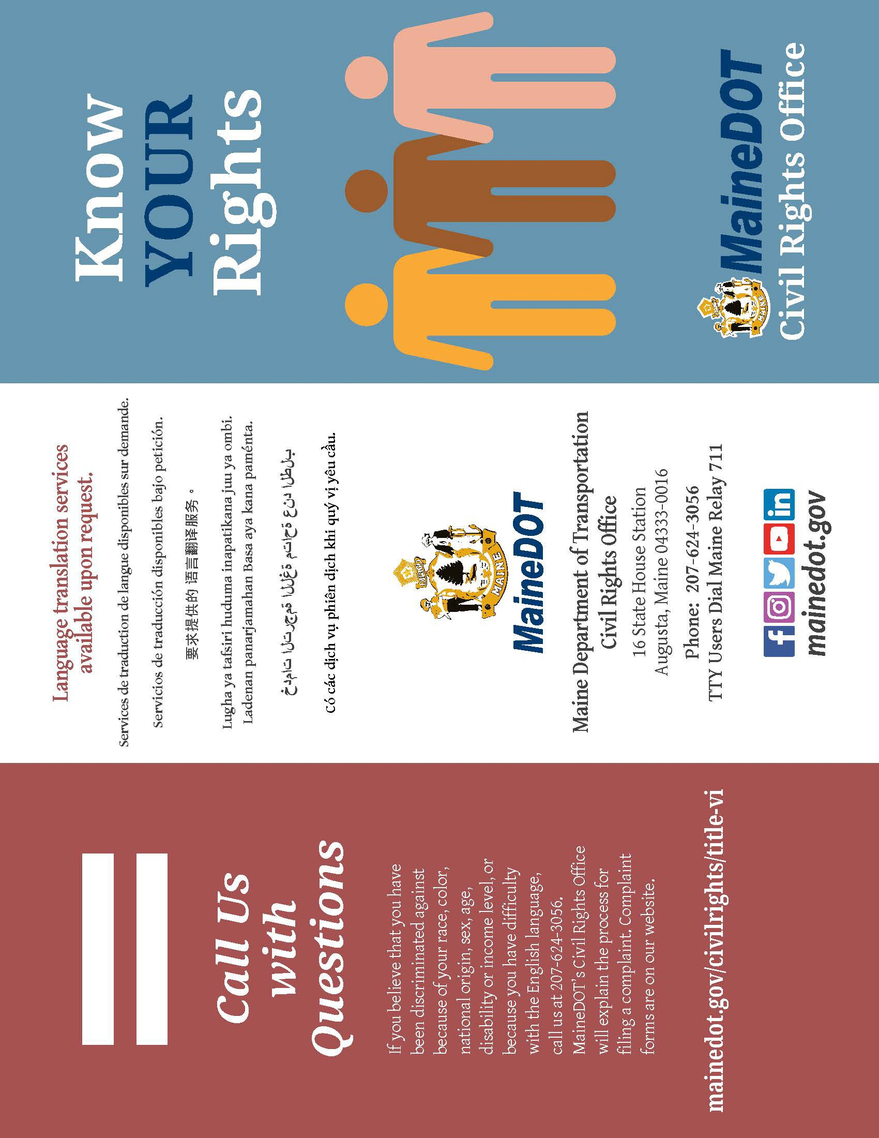

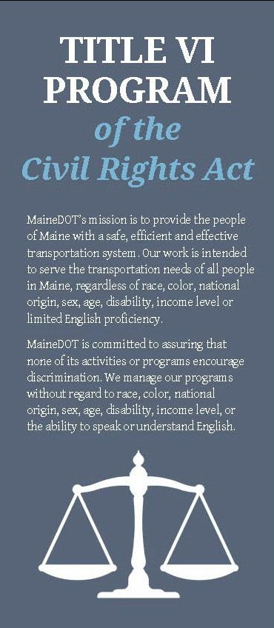
MaineDOT will not allow discriminationby
a MaineOOT employee or by recipients of federal-aid funds such as dies, counties,
contractors, or planning agencies. MaineDOT prohibits all discriminatory practices which may result in:
- Unfair denial of any service, financial aid or benefit providedby the federally funded prcgram;
- Different standards or requirements for participation in programs;
- Segregation or separate treatment within our programs;
- Differences in the quality, quantity or way in which a benefit is provided;
- Discrimination in any activities in a facility builtwith federal funds.

To ensure compliance with Title VI, and other related laws, MaineDOT:
- Avoids or reduces hannful health and environmental impacts which prcgrams or activities might have on minority and low-income populations;
- Ensures the full and fair participation by all communities in its decision-making process;
- Prevents the denial, recb..iction or delay of benefits for minority and low-income populations;
- Provides language interpreters to people who have difficulty understanding English.
How to File a Complaint
If you believe you have been discriminated against, you will need to file a written complaint. The com plaint must be submitted within 180 days of the alleged discrimination. The com plaint form is on our website for you to download.
.Be prepared to fill in:
- Your name, address and phone number;
- The name and address of the organization you believe discriminated against you;
- Details of the alleged discrimination and any other relevant information; and
- The names of anyone we could contact regarding the alleged discrimination.

0nm you have filled in thefonn, mail it to us:
MaineDOT Civil Rights Office
16 State House Station Augusta, Maine 04333-0016
207-624-3056

